Title
Name Surname* – Name Surname**
Abstract. Maximum: 15 lines. Text text text. Text text text text text text. Text text text. Text text text. Text text text text text text. Text text text.
Second paragraph of the abstract. Text text text. Text text text text text text. Text text text.
Keywords: lorem, ipsum, dolor, sit, amet.
JEL Classification: B22

Maximum of the contribution: 8 pages (including abstract).

Introduction (title of the chapter of 1st level)
First paragraph of the section. Text text text. Text text text text text text. Text text text. Text text text. Text text text text text text. Text text text.
Second and following paragraphs of the text. Text text text. Text text text text text text. Text text text. Text text text. Text text text text text text. Text text text.

Title of the subchapter (2nd level)
First paragraph of the section. Text text text. Text text text text text text. Text text text. Text text text. Text text text text text text. Text text text.
Second and following paragraphs of the text. Text text text. Text text text text text text. Text text text. Text text text. Text text text text text text. Text text text.

Other subheading (not numbered)
First paragraph of the section. Text text text. Text text text text text text. Text text text. Text text text. Text text text text text text. Text text text.
Second and following paragraphs of the text. Text text text. Text text text text text text. Text text text. Text text text. Text text text text text text. Text text text.

Ordered and unordered lists
Text text text. Text text text text text text. Text text text. Text text text. Text text text text text text. Text text text. Unordered list:
- text text,
- text text,
- text text,
- text text.
Next paragraph is indented as an ordinary (not first) paragraph. Text text text text text text. Text text text. Text text text. Text text text text text text. Text text text. Ordered list:
- first item of the list;
- second item with a sublist:
  - first item in the sublist,
  - second item in the sublist,
- parent list continued.
Ordered and unordered lists may be freely combined. Text text text text text text. Text text text. Text text text. Text text text text text text. Text text text.

Figures
Figures have to be centered, numbered continuously, and referenced in the text. Please, use only black or white colors.
Figure 1: Heading of the graph

Source: Data source.

Tables
Tables have to be centered, numbered continuously, and referenced in the text. Please, use caption format as given here.
Table 1: Heading of the table
First | Second | Third | Sum
Text | Text | number | number
Text | Text | number | number
Source: Data source.

Equations
Equations have to be centered and right-numbered continuously. Please use 10pt sized font.
, |  |  |  | (1)
where | X | = | quantity,
 | EX | = | quantity.

Conclusions

Figures
Figures have to be centered, numbered continuously, and referenced in the text. Please, use only black or white colors.
Figure 2: Heading of the graph

Source: Data source.

Tables
Tables have to be centered, numbered continuously, and referenced in the text. Please, use caption format as given here.
Table 2: Heading of the table
First | Second | Third | Sum
Text | Text | number | number
Text | Text | number | number
Source: Data source.

Acknowledgements
Supporting people and institutions (including Science Foundations), for example: The contribution is processed as an output of a research project Name of the project registered by the name of the agency/ministry under the registration number 0000.
Table 3: Heading of the table
First | Second | Third | Sum
Text | Text | number | number
Text | Text | number | number
Source: Data source.
Table 4: Heading of the table
First | Second | Third | Sum
Text | Text | number | number
Text | Text | number | number
Source: Data source.
Table 5: Heading of the table
First | Second | Third | Sum
Text | Text | number | number
Text | Text | number | number
Source: Data source.

References (alphabetically, reference style ČSN ISO 690)
KEEN, Michael and SLEMROD, Joel, 2016. Optimal Tax Administration [online]. Working Paper. National Bureau of Economic Research. [Accessed 10 January 2019]. Available from: http://www.nber.org/papers/w22408
KEEN, Michael, 2018. Bank Taxes, Bailouts and Financial Crises. [online]. March 2018. [Accessed 10 January 2019]. Available from: https://www.ingentaconnect.com/contentone/mohr/fa/2018/00000074/00000001/art00002
KLAZAR, Stanislav, SEDMIHRADSKÝ, Milan and VANČUROVÁ, Alena, 2001. Returns of Education in the Czech Republic. International Tax and Public Finance. 1 August 2001. Vol. 8, no. 4, p. 609–620. DOI 10.1023/A:1011232805929
PAVEL, Jan, KLAZAR, Stanislav and ŠUMPÍKOVÁ, Markéta, 2003. Ekonometrická analýza regionální absorpce veřejných výdajových programů v České republice [Econometric Analysis of Regional Absorption]. In: MALACH, Antonín. Podpora podnikání v regionech ČR a EU. Brno: Masarykova univerzita v Brně. 13 April 2003. p. 129–133. ISBN 80-210-3259-6.

Recommended software ZOTERO
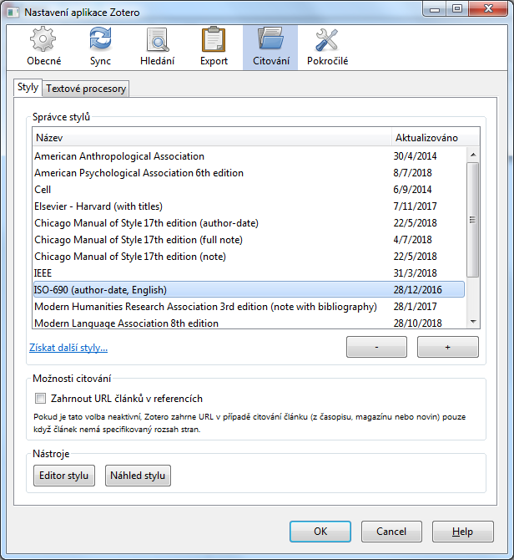

* Academic degree Name Surname; full contact address, e-mail@xxx.cz. (doc. Ing. Pavel Novák, Ph.D.; Department of Public Finance Faculty of Finance and Accounting, University of Economics, Prague, W. Churchill Sq. 4, 130 67 Prague, Czech Republic, pavel.novak@vse.cz)
** Academic degree Name Surname; full contact address, e-mail@xxx.cz.

